* Create s3 replica rule

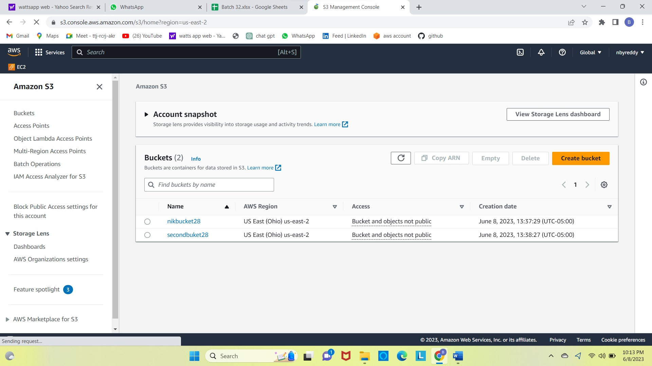

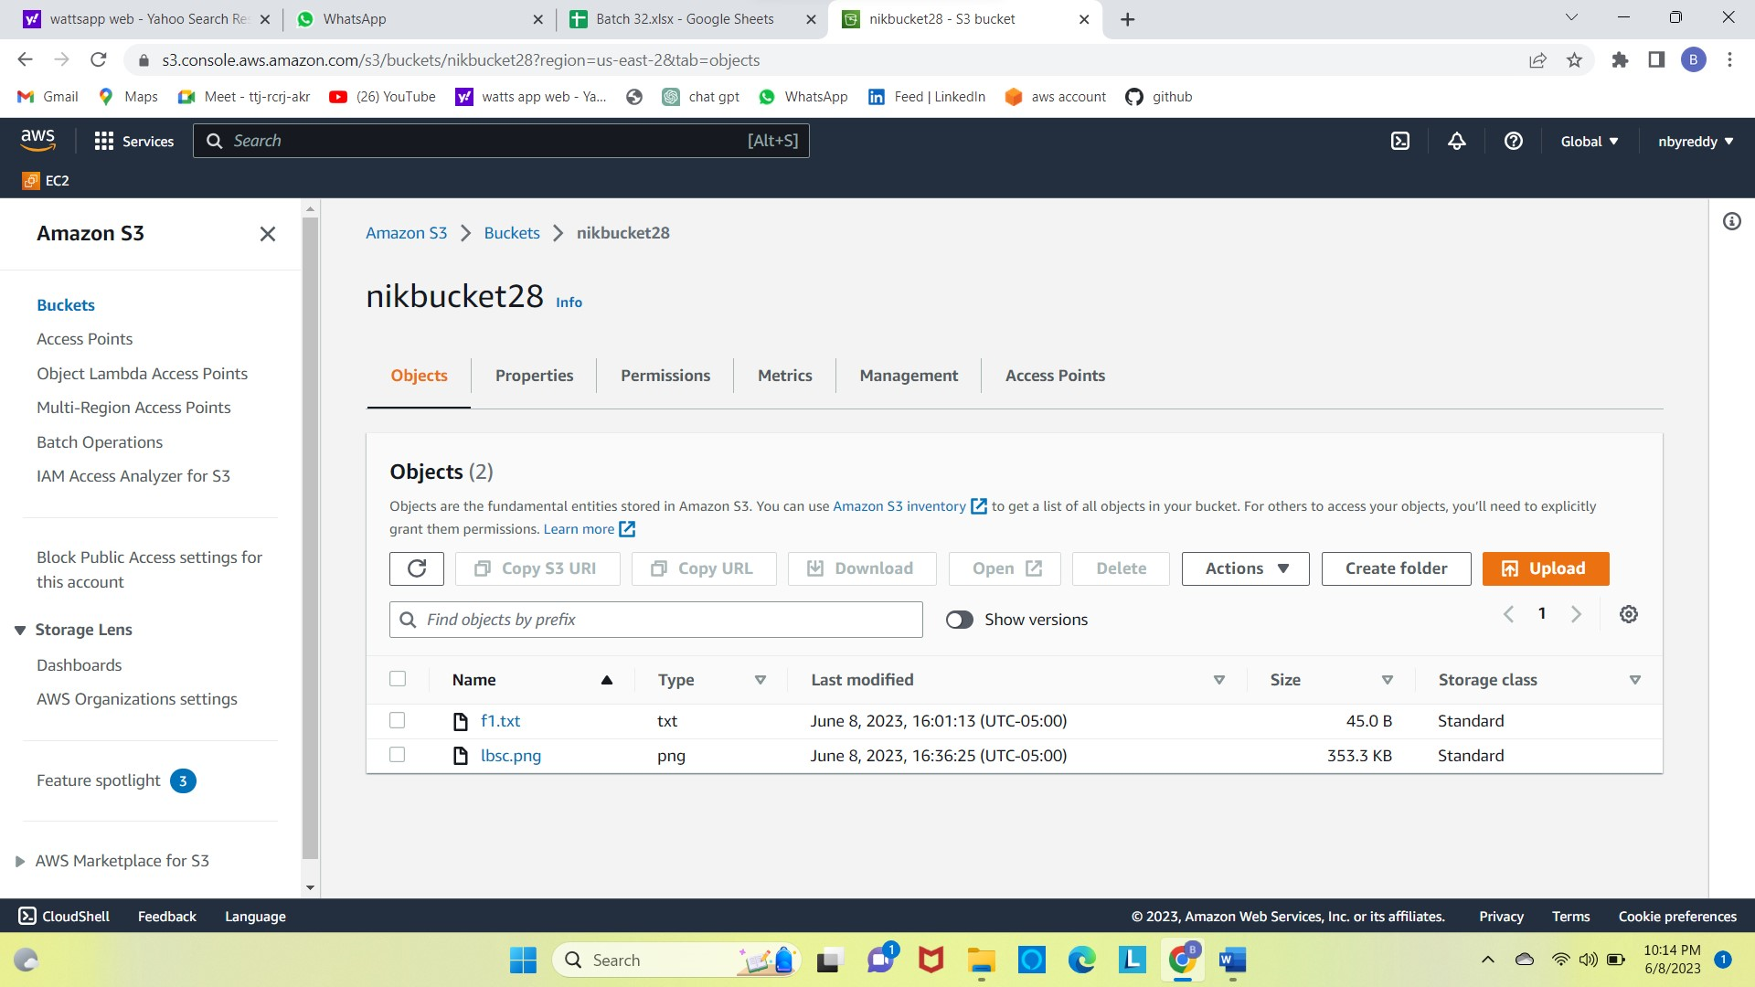

Here I have created 2 buckets in one of the bucket I have created replication rules and uploaded files from documents and that got replicated it to the other bucket as shown in the fig

\*Copy file from ec2 to s3

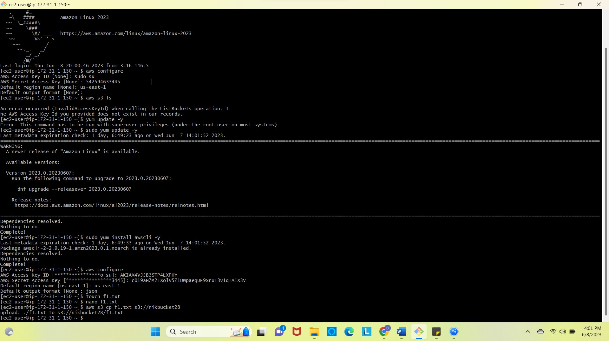



\*this is my ec2 instances after creating user and gave permissions only to ec2



